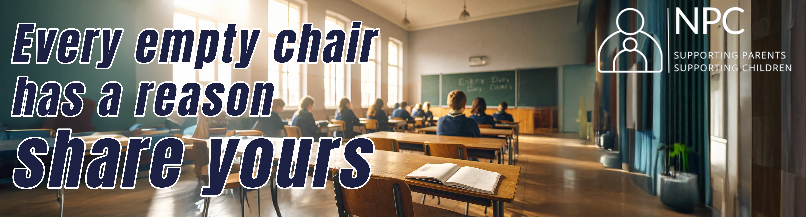
Dear Parents,
You may have noticed that school attendance has been a topic of growing discussion in the media recently. To better understand the reasons behind student absences and to help create more effective ways to support students and parents, the National Parents Council (NPC) is contacting you to get your views on the issues that are impacting students’ attendance.
Your insights and experiences are incredibly valuable. By sharing your perspective, you can help shape strategies that ensure every child feels supported and has the opportunity to thrive in school. The NPC is also very interested in hearing directly from your children about their own experiences and thoughts on attending school.
To gather this feedback, the NPC has created two short surveys—one for parents and one for students. We kindly invite you and your child to take a few moments to complete the relevant survey below:
For Primary School Families:
- School Attendance – Survey for Parents (Primary)
- Helping Every Child Go To School – Survey for Children (Primary)
For Post-Primary School Families:
- School Attendance – Survey for Parents (Post-Primary)
- Why Do Students Miss School? Let’s Talk! – Survey for Students (Post-Primary)
Thank you for your time and for helping make school a more inclusive and supportive environment for all students.
Warm regards
National Parents Council
****************************************************************************************
Please consider the Environment before printing this email
NPC is on: Facebook & Instagram
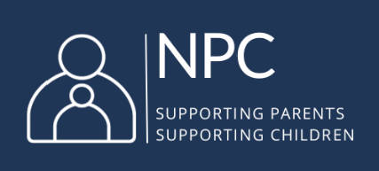
National Parents Council Primary (Company limited by guarantee)
Registered Business Name: National Parents Council
Registered: Dublin
Company Registration Number: 733907 Charity Number: Chy10547 Registered Charity Number: 20027032
Registered Address:
12 Marlborough Court
Marlborough Street
Dublin 1
D01 XP86
Tel: 00 353 1 8874034
Helpline: 00 353 1 8874477
www.npc.ie
**************************************************************************
“The information transmitted is intended only for the person or entity to which it is addressed and may contain confidential and / or privileged material. Any review, retransmission, dissemination or other use of, or taking of any action in reliance upon, this information by persons or entities other than the intended recipient is prohibited. If you received this in error, please contact the sender and delete the material from any computer. It is the policy of National Parents Council to disallow the sending of offensive material and should you consider that the material contained in the message is offensive you should contact the sender immediately and also your IT manager”.

